RETAIL SALES PERFORMANCE AND PROFITABILITY ANALYSIS

Data Analytics Project

Tools Used:
Excel | PostgreSQL | Python (Pandas) | Power BI

Dataset:
1,000 Retail Transactions

Prepared by : John Joshua J
Date: September 2026

ABSTRACT

This project presents an end-to-end analysis of retail sales data to evaluate sales performance, profitability, customer segments, geographical performance, payment preferences, and monthly sales trends. The analysis was performed using Microsoft Excel, PostgreSQL, Python (Pandas), and Power BI.
The dataset contains retail transaction records covering the period from January 2025 to December 2025, with information related to customers, products, sales, discounts, profits, cities, regions, and payment methods. The data was first cleaned and validated using Excel by identifying duplicate records, missing values, and data-quality issues. PostgreSQL was then used to perform SQL-based aggregation, filtering, product analysis, monthly trend analysis, and profitability analysis. Python and Pandas were used to further analyze and validate the results programmatically.
The analysis identified important business patterns, including the strong contribution of Furniture to total sales and profit, the higher profit margin of Electronics, the strong sales contribution from Consumer customers, and the high usage of UPI as a payment method. Jaipur recorded the highest city-level sales, while July recorded the highest monthly sales during the analysis period.
Finally, the results were presented through an interactive Power BI dashboard, enabling users to explore sales performance across categories, cities, customer segments, and time periods. The project demonstrates the complete data analytics workflow from data cleaning and exploration to SQL analysis, Python programming, visualization, and business insight generation.

INTRODUCTION

Retail businesses generate large amounts of data through customer transactions, product sales, payments, discounts, and orders. Analyzing this data can help businesses understand their sales performance, profitability, customer behavior, and changing market trends.

This project focuses on analyzing a retail sales dataset containing transaction information from different cities and customer segments in India during 2025. The analysis examines key areas such as sales, profit, product categories, customer segments, geographical performance, payment methods, discounts, and monthly sales trends.

An end-to-end data analytics approach was followed using Microsoft Excel, PostgreSQL, Python (Pandas), and Power BI. Excel was used for data cleaning and exploratory analysis, PostgreSQL for SQL-based analysis, Python for programmatic data analysis and validation, and Power BI for interactive visualization and dashboard creation.

The project aims to transform raw retail transaction data into meaningful business insights that can support better understanding of sales performance and profitability.

PROJECT OBJECTIVE

The main objective of this project is to analyze retail sales data and identify meaningful patterns in sales performance, profitability, customer segments, geographical performance, payment methods, and monthly sales trends.

The specific objectives of the project are:

To clean and validate the retail sales dataset and identify data-quality issues.
To analyze sales, profit, quantity, and profit margins using Excel.
To use PostgreSQL and SQL queries for data aggregation, filtering, and deeper analysis.
To use Python and Pandas to perform programmatic analysis and validate the results.
To identify top-performing categories, products, cities, and customer segments.
To analyze monthly sales trends and payment preferences.
To examine the relationship between discount levels and profitability.
To create an interactive Power BI dashboard for visualizing key business metrics.
To generate business insights and recommendations based on the analysis.

DATASET DESCRIPTION

The dataset used in this project contains 1,000 retail transaction records. The data represents sales transactions across multiple cities in India and includes information about orders, customers, products, sales, discounts, profits and payment methods.

Field | Description
Number of Records | 1,000
Number of Columns | 18
Time Period | January 2025 – December 2025
Customer Information | Customer ID, Customer Name, Segment
Product Information | Category, Product, Quantity
Sales Information | Sales, Discount, Profit
Location Information | City, Region

TOOLS AND TECHNOLOGIES

Tool | Purpose
Excel | Data cleaning and exploratory analysis
PostgreSQL | SQL querying and data aggregation
Python | Data analysis using Pandas
Power BI | Interactive dashboard and visualization

DATA CLEANING

Before performing the analysis, the dataset was reviewed for duplicate records, missing values and invalid data entries. Excel was used to identify and handle the data-quality issues before the cleaned dataset was used for further analysis.

Duplicate Records
Duplicate records were identified by checking the dataset for repeated Row IDs and comparing the corresponding records. Two duplicate records were identified and removed using Excel's Remove Duplicates feature. After removing the duplicates, the dataset contained 1,000 records.

Missing Values
Missing values were identified in four columns: Customer Name, Quantity, Sales and Payment Mode. Since reliable replacement values were not available, the missing values were retained as blank/NULL values rather than being replaced with assumed values.
Column | Missing Values | Treatment
Customer Name | 1 | Retained as NULL
Quantity | 1 | Retained as NULL
Sales | 1 | Retained as NULL
Payment Mode | 1 | Retained as NULL

Data Validation
Additional validation checks were performed on important fields. A Ship Date occurring before the corresponding Order Date was identified as an invalid value. A non-positive Quantity value was also identified as a data-quality issue. Negative profit values were retained because a negative profit can represent a genuine business loss on a transaction.

Final Dataset
After duplicate removal and data-quality checks, the final dataset contained 1,000 records and 18 columns. This cleaned dataset was subsequently used for Excel analysis, PostgreSQL queries, Python analysis and the Power BI dashboard.
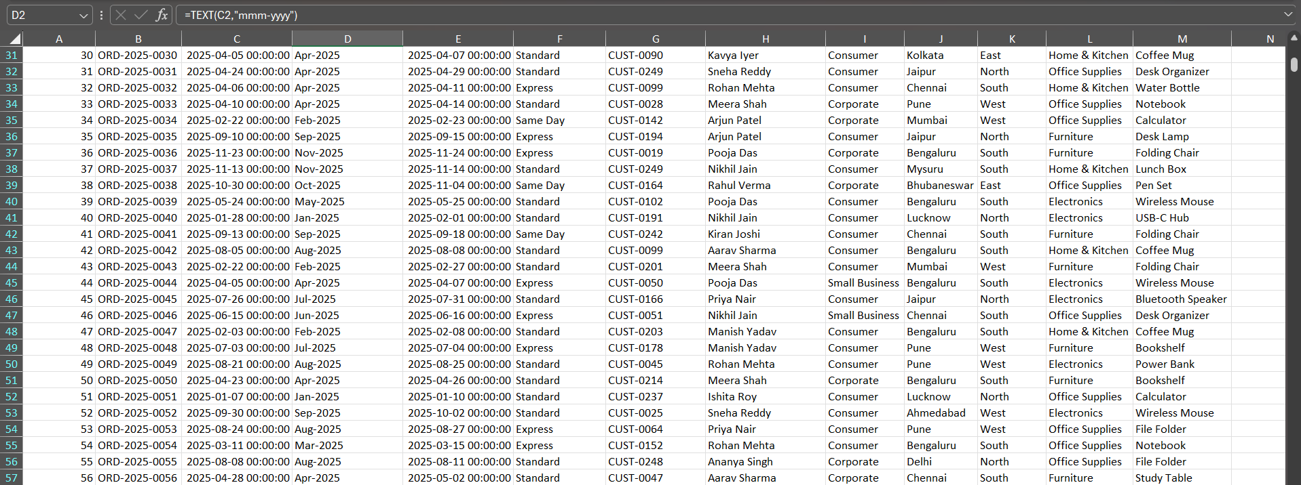
Figure 1: Cleaned and validated retail sales dataset

Exploratory Data Analysis Using Excel

After cleaning the dataset, exploratory data analysis (EDA) was performed using Microsoft Excel. PivotTables and calculated measures were used to understand overall sales, profitability, category performance, city-level performance, customer segments, payment methods and monthly sales trends.

Key Performance Indicators
KPI | Value
Total Sales | ₹31,96,916.71
Total Profit | ₹6,60,060.13
Total Quantity | 2,203
Total Transactions | 1,000
Overall Profit Margin | 20.6%

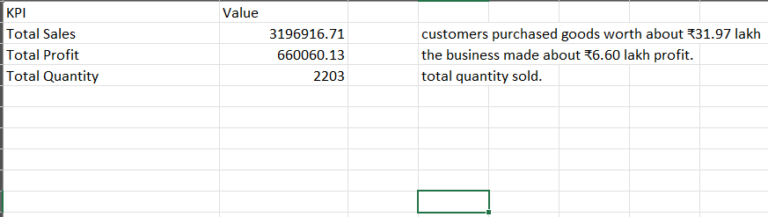
Figure 2 : Excel-based KPI and category analysis

The analysis shows total sales of approximately ₹31.97 lakh and total profit of approximately ₹6.60 lakh, resulting in an overall profit margin of approximately 20.6%.

Sales and Profit by Category
Category-level analysis was performed using a PivotTable to compare total sales and total profit.
Category | Sales | Profit
Furniture | ₹18,80,322.79 | ₹3,86,010.92
Electronics | ₹7,51,422.01 | ₹1,59,717.33
Home & Kitchen | ₹4,23,744.48 | ₹84,586.19
Office Supplies | ₹1,41,427.43 | ₹29,745.69

Furniture generated the highest sales and absolute profit among the four categories. Electronics recorded the highest category-level profit margin at approximately 21.3%.

Sales by City
Sales were analyzed across 12 cities to understand geographical variation in sales performance.
Jaipur recorded the highest sales at approximately ₹4.07 lakh, while Hyderabad recorded the lowest sales at approximately ₹2.04 lakh.

Sales by Customer Segment
Customer segment analysis showed that Consumer customers generated the largest share of sales.
Segment | Sales | Approx. Share
Consumer | ₹16,43,758.89 | 51.4%
Corporate | ₹9,63,128.17 | 30.1%
Small Business | ₹5,90,029.65 | 18.5%

Payment Mode Analysis
Payment-mode analysis showed that UPI generated the highest sales value, contributing approximately 43% of total sales. Credit Card and Debit Card were the next major payment categories.

Monthly Sales Trend
Monthly sales were analyzed to identify changes in sales performance throughout 2025. July recorded the highest monthly sales at approximately ₹3.27 lakh, while September recorded the lowest at approximately ₹1.95 lakh.

SQL Analysis Using PostgreSQL

PostgreSQL was used to perform structured querying and aggregation on the cleaned retail sales dataset. SQL queries were used to validate the dataset and analyze sales, profit, products, customer segments, monthly trends and discount levels.

Database and Data Validation
A PostgreSQL database named retail_sales was created and the cleaned CSV dataset was imported into a table named sales_data. The imported dataset was validated by checking the number of records, date range and overall sales, profit and quantity totals.
Validation | Result
Total Records | 1,000
Earliest Order Date | 1 January 2025
Latest Order Date | 31 December 2025
Total Sales | ₹31,96,916.71
Total Profit | ₹6,60,060.13
Total Quantity | 2,203

Category Analysis
SQL GROUP BY and aggregate functions were used to calculate total sales and profit for each product category. The results were sorted using ORDER BY to identify the categories with higher sales.
The main SQL concepts used were:
SELECT
SUM()
GROUP BY
ORDER BY
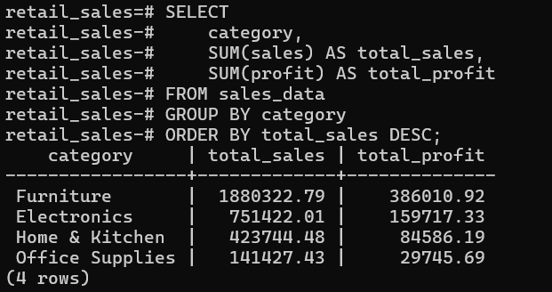
Figure 3 : PostgreSQL SQL query and category-wise analysis output

Filtering and Conditional Analysis
The WHERE clause was used to filter records for specific analysis, such as analyzing Furniture products. The HAVING clause was used to filter grouped results based on aggregate values. CASE WHEN statements were also used to classify transactions into categories such as High Value, Medium Value and Low Value sales.
SQL concepts:
WHERE
HAVING
CASE WHEN

Product Analysis
Product-level sales and profit were aggregated using SQL to identify the top 10 products based on total sales. This analysis helped identify products that contributed significantly to overall revenue.

7.5 Monthly Sales Analysis
Monthly sales were calculated using PostgreSQL date functions. DATE_TRUNC() was used to group transactions by month, while TO_CHAR() was used to display the month in a readable format.

7.6 Discount and Profitability Analysis
Discount levels were classified into Low Discount, Medium Discount and High Discount using CASE WHEN. Sales, profit and profit margin were then calculated for each discount category to examine the relationship between discount levels and profitability.

7.7 SQL Skills Demonstrated
Through the SQL analysis, the project demonstrated practical use of data aggregation, filtering, grouping, sorting, conditional logic, date functions and profitability calculations in PostgreSQL.

Python/Pandas Analysis

Python was used to perform data analysis and validate the results obtained from Excel and PostgreSQL. The Pandas library was used to load the cleaned dataset, inspect the data, calculate key performance indicators, perform grouping and aggregation, analyze monthly sales trends, identify top-performing products, and examine discount levels and profitability.
The Python analysis helped automate repetitive calculations and provided an additional way to verify the results from the earlier stages of the project.

Loading and Inspecting the Dataset
The cleaned CSV file was loaded into Python using Pandas. The dataset was inspected using functions such as head(), shape, info() and isnull().sum().
The analysis confirmed that the dataset contained 1,000 records and 18 columns. Missing values were also identified in Customer Name, Quantity, Sales and Payment Mode.

Key Performance Indicators
Python was used to calculate the main business KPIs:
KPI | Value
Total Sales | ₹31,96,916.71
Total Profit | ₹6,60,060.13
Total Quantity | 2,203
Total Orders | 1,000
Overall Profit Margin | 20.6%
These results matched the calculations performed during the Excel and PostgreSQL stages, providing consistency across the analysis.
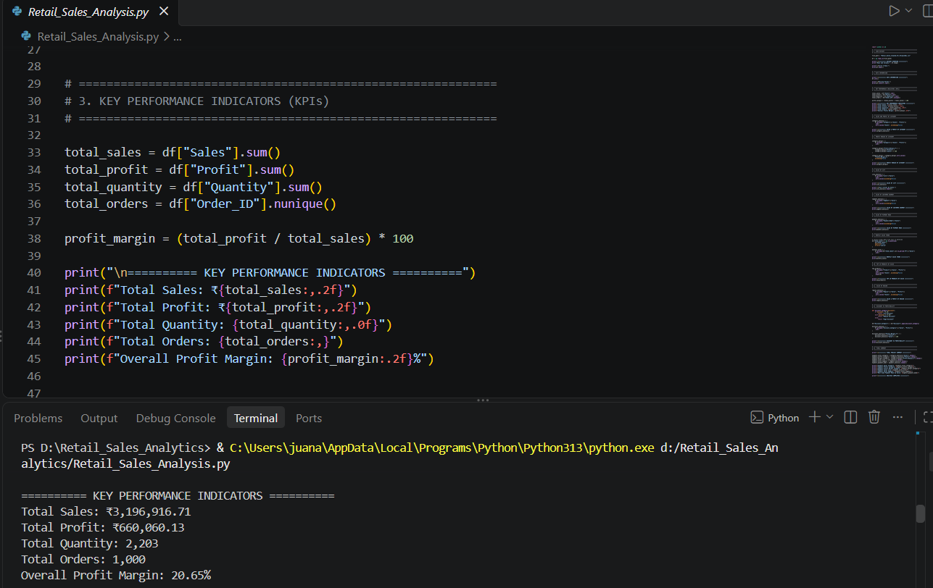
Figure 4 : Python and Pandas KPI analysis output

Category Analysis
Pandas groupby() was used to calculate total sales and profit for each product category.
The analysis showed that Furniture generated the highest sales and absolute profit, while Electronics had the highest profit margin, at approximately 21.3%.

City and Customer Segment Analysis
Python was also used to aggregate sales by city and customer segment.
The city analysis identified Jaipur as the city with the highest total sales. The segment analysis showed that Consumer customers contributed the largest share of total sales.

Payment Mode Analysis
Sales were grouped according to payment mode using Pandas.
The analysis showed that UPI generated the highest sales value, contributing approximately 43% of total sales.

Monthly Sales Trend
The Order_Date column was converted into a proper date format using Pandas. Monthly sales were then calculated using date-based grouping.
The analysis showed that July recorded the highest monthly sales, while September recorded the lowest monthly sales during 2025.

Top 10 Products
Python was used to identify the top 10 products based on total sales.
Sales and profit were aggregated at the product level and sorted in descending order. This helped identify products that made significant contributions to overall revenue.

Discount and Profitability Analysis
Discount levels were classified into three groups:
- Low Discount
- Medium Discount
- High Discount
Python was then used to calculate sales, profit and profit margin for each discount category. This analysis was used to understand how different discount levels were associated with profitability.

8.9 Python Skills Demonstrated
The Python/Pandas stage demonstrated practical use of:
- Reading CSV files
- DataFrame inspection
- Missing-value analysis
- groupby()
- Aggregation using sum()
- Sorting using sort_values()
- Date conversion using to_datetime()
- Monthly analysis using to_period()
- Conditional classification using Python functions
- Profit-margin calculations
- Basic data validation

Summary
Python provided an additional analytical layer to the project and helped verify the results obtained from Excel and PostgreSQL. The use of Pandas demonstrated how Python can be used to efficiently analyze and summarize retail transaction data.

Power BI Dashboard

Power BI was used to create an interactive dashboard for visualizing the results of the retail sales analysis. The cleaned dataset was imported into Power BI, and different charts, KPI cards and slicers were created to present the key findings in an easy-to-understand format.

The dashboard provides an overall view of sales performance, profitability, customer segments, geographical performance and monthly sales trends.

9.1 KPI Cards
The dashboard contains four key performance indicators:
KPI | Value
Total Sales | ₹31,96,916.71
Total Profit | ₹6,60,060.13
Total Orders | 1,000
Total Quantity | 2,203
These KPIs provide a quick summary of the overall business performance.

9.2 Sales by Category
A column chart was created to compare sales across different product categories.
The visualization shows that Furniture generated the highest sales, followed by Electronics, Home & Kitchen and Office Supplies.

9.3 Sales by City
A bar chart was used to compare sales across the 12 cities included in the dataset.
The visualization helps identify differences in sales performance between cities. Jaipur recorded the highest sales, while Hyderabad recorded the lowest sales.

9.4 Sales by Customer Segment
A column chart was created to analyze sales across customer segments.
The analysis showed that Consumer customers generated the largest share of sales, followed by Corporate and Small Business customers.

9.5 Monthly Sales Trend
A line chart was created to visualize sales throughout 2025.
The chart helps identify changes in sales performance across different months. July recorded the highest monthly sales, while September recorded the lowest monthly sales.

9.6 Sales vs Profit by Category
A clustered column chart was created to compare sales and profit across product categories.
This visualization makes it easier to understand the relationship between revenue generation and profitability for each category.

9.7 Interactive Slicers
Three slicers were added to make the dashboard interactive:
- City
- Category
- Segment
Users can select values from these slicers to dynamically filter the dashboard and examine specific parts of the dataset.

9.8 Dashboard Layout
The dashboard was organized into different sections:
- KPI cards at the top for overall performance
- Category and city analysis
- Customer segment analysis
- Monthly sales trend
- Sales versus profit comparison
- Interactive slicers for filtering
This layout allows users to quickly understand the overall performance and then explore specific areas of the business.
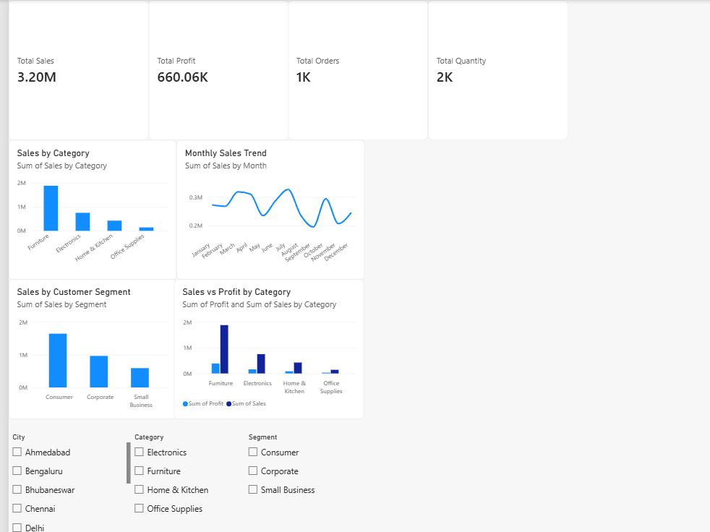
Figure 5 : Interactive Power BI retail sales dashboard

9.9 Summary
The Power BI dashboard transformed the results from Excel, PostgreSQL and Python into an interactive visual report. It allows business users to explore sales performance across categories, cities, customer segments and time periods without directly working with the underlying dataset.

Business Insights & Recommendations

The analysis performed using Excel, PostgreSQL, Python and Power BI helped identify several important patterns in the retail dataset. These insights can be used to understand sales performance, profitability and customer behavior.

10.1 Key Business Insights

1. Overall Performance
The dataset generated total sales of approximately ₹31.97 lakh and total profit of approximately ₹6.60 lakh, with an overall profit margin of approximately 20.6%.

2. Category Performance
Furniture generated the highest sales and absolute profit among the four categories. Electronics recorded the highest category-level profit margin at approximately 21.3%.

3. City Performance
There was variation in sales across cities. Jaipur recorded the highest sales at approximately ₹4.07 lakh, while Hyderabad recorded the lowest at approximately ₹2.04 lakh.

4. Customer Segment
Consumer customers contributed the largest share of sales, approximately 51.4% of total sales. Corporate customers contributed approximately 30.1%, while Small Business customers contributed approximately 18.5%.

5. Payment Preferences
UPI generated the highest sales value, contributing approximately 43% of total sales. Credit Card and Debit Card were the next major payment categories.

6. Monthly Sales
Sales varied across the year. July recorded the highest monthly sales at approximately ₹3.27 lakh, while September recorded the lowest at approximately ₹1.95 lakh.

10.2 Recommendations
Based on the observed patterns, the following recommendations can be considered:

1. Monitor Furniture Performance
Furniture is the largest contributor to sales and absolute profit. Individual Furniture products can be analyzed further to understand which products contribute most to revenue and profit.

2. Investigate City-Level Differences
The variation between cities can be investigated using factors such as product mix, order volume, customer segment and demand patterns. This can help understand why sales differ across locations.

3. Focus on Consumer Customer Patterns
Since Consumer customers contribute the largest share of sales, their purchasing patterns can be analyzed further to identify opportunities for repeat purchases and customer retention.

4. Monitor Discounts and Profitability
Discount levels should be monitored together with profit margins. Higher discounts may affect profitability, so discount strategies can be evaluated using transaction-level performance.

5. Use Monthly Trends for Planning
Monthly sales trends can support inventory, promotional and resource planning, particularly during months with relatively higher or lower sales.

10.3 Summary
The analysis demonstrates how data can be used to identify sales patterns and support business decision-making. The insights from this project provide a starting point for deeper analysis of products, customers, cities, discounts and sales trends.

11. Conclusion

This project analyzed retail sales transaction data to understand sales performance, profitability, customer segments, geographical performance, payment preferences and monthly sales trends.
The project followed an end-to-end data analytics workflow using Excel, PostgreSQL, Python/Pandas and Power BI. Excel was used for data cleaning and exploratory analysis, PostgreSQL was used for SQL-based analysis, Python was used for programmatic data analysis, and Power BI was used to create an interactive dashboard.
The analysis identified important patterns such as the strong contribution of Furniture to overall sales, the high sales contribution from Consumer customers, the dominance of UPI as a payment mode, and variations in sales across cities and months.
Overall, the project demonstrates how raw transactional data can be transformed into meaningful business insights using commonly used data analytics tools.

11.1 Future Scope
The project can be extended in several ways:
- Analyze individual customer purchasing behavior.
- Identify repeat customers and customer retention patterns.
- Perform product-level profitability analysis.
- Analyze the relationship between discounts and profit in greater detail.
- Build sales forecasting models using historical monthly data.
- Add more advanced Power BI measures using DAX.
- Automate the data-cleaning and reporting process.
- Incorporate additional business data such as costs, inventory and customer acquisition information.

11.2 Final Summary
This project provided practical experience in the complete data analytics lifecycle, from data cleaning and exploration to SQL analysis, Python programming, visualization and business reporting.
The combination of multiple tools demonstrates the ability to work with data at different stages and convert analytical results into a clear business-oriented dashboard and report.

12. REFERENCES

1. Microsoft. Microsoft Excel Documentation.
https://support.microsoft.com/excel

2. PostgreSQL Global Development Group. PostgreSQL Documentation.
https://www.postgresql.org/docs/

3. Python Software Foundation. Python Documentation.
https://docs.python.org/3/

4. Pandas Development Team. Pandas Documentation.
https://pandas.pydata.org/docs/

5. Microsoft. Power BI Documentation.
https://learn.microsoft.com/power-bi/

